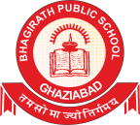

BHAGIRATH PUBLIC
SCHOOL
At
A Glance
Session
2025
Syllabus
2024-

Subject Mathematics
Class 3

Subject
Priya
Month Name of the Chapters Activities Exam Cycle
Undertaken
Teacher :Kannu
Srivastava

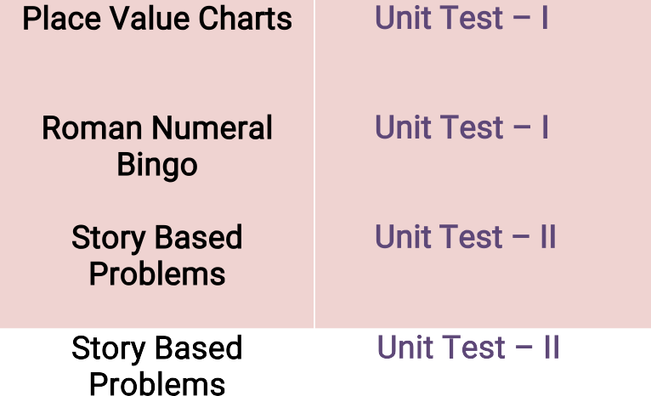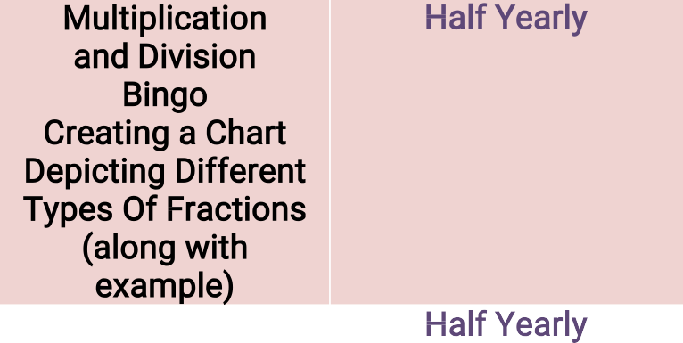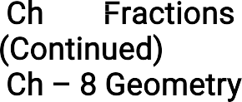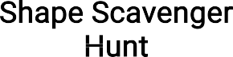
April

May

August
July
1. Ch –1 –
4 – Digit Numbers

- Ch – 2 Roman Numbers

- Ch -3 Addition Of 4 – Digit Numbers

- Ch – 4 Subtraction Of 4 – Digit Numbers
- Ch – 5 Multiplication

- Ch – 6 Division
- Ch – 7 Fractions

Ch – 7 Fractions (Continued)
- Ch – 8 Geometry
Place Value Charts

Roman Numeral Bingo

Story Based Problems

Story Based Problems Multiplication and Division Bingo
Creating a Chart Depicting Different Types Of Fractions (along with example)

Shape Scavenger Hunt
Unit Test – I Unit Test – I Unit Test – II
Unit Test – II Half Yearly

Half Yearly

- Ch – 9 Patterns Puzzle Revision For Half – YearlyExamination
January
December
November
October
September

- Ch – 10 Money
Ch
Market Place Recreation
Unit Test – III Unit Test - IV

– 11
Time Matching Game

- Ch – 12 Length
Time

- Ch – 13 Weight
14. Ch – 14 Capacity
Outdoor Nature Walk
Weight Sorting Measuring Cup Exploration
Annual Examination Annual Examination

Annual Examination

February
Handling
Ch – 15 Data
15.
Revision For Annual Examination
Worksheet Annual Examination
Annual Examination

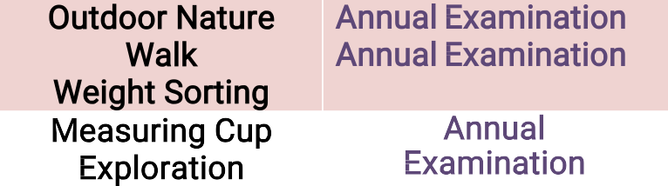
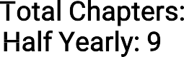15
Overview: Total Chapters: Half Yearly: 9
Annual
Examination: 6

